Surveillance-based R(t) estimation for respiratory pathogen onset detection: a retrospective cross-pathogen evaluation of influenza and RSV in Hong Kong, 2014–2026
Thomas Yuan, Vijaykrishna Dhanasekaran
Figures 1 to 4
Version: 2026-10-15, v10 (supersedes figures_v9 of 26 September 2026). Figure 2 is replaced and Figure 4 is regenerated with a corrected title and otherwise identical data; Figures 1 and 3 are unchanged from v9. All values generated from the repository at https://github.com/thomasshuaiyuan/pinn-early-warning.
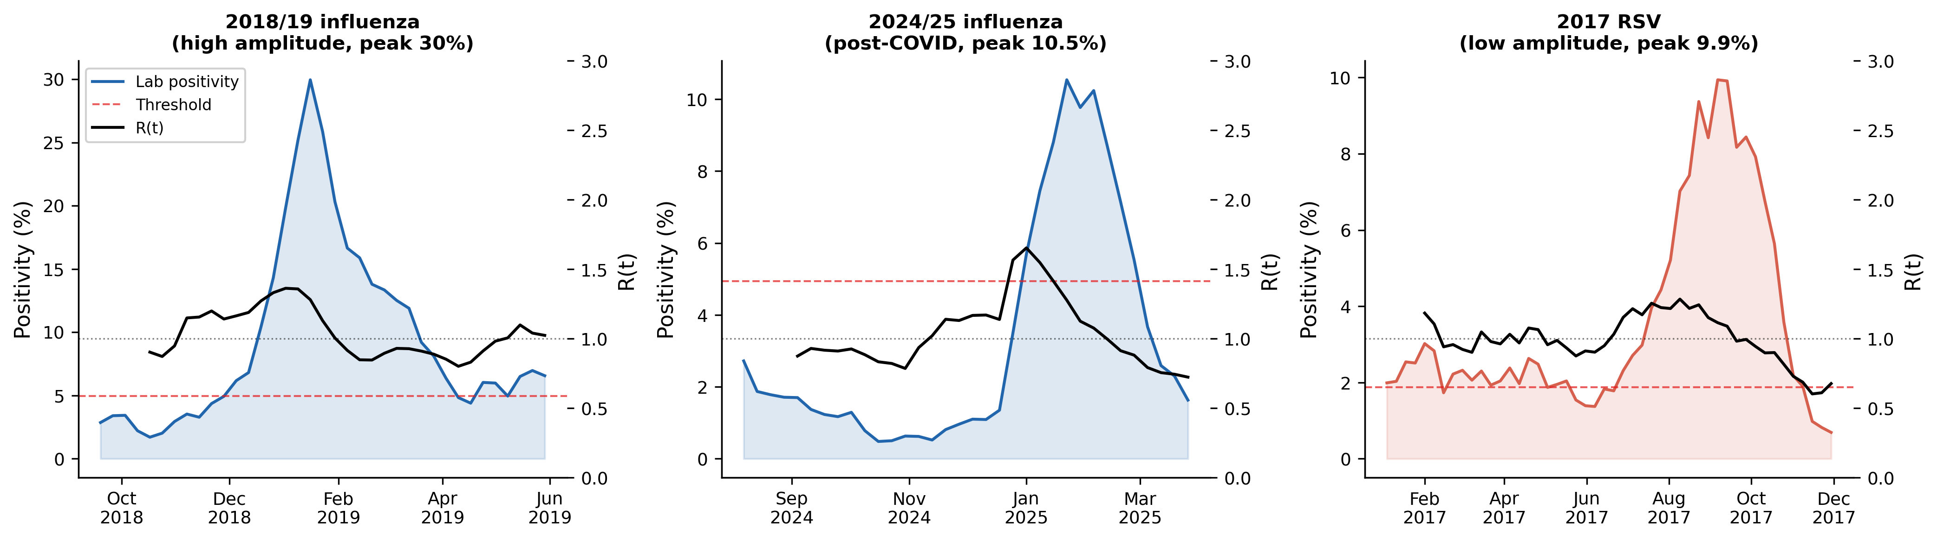
Figure 1. Representative R(t) trajectories. Weekly laboratory positivity (shaded) and EpiEstim posterior mean R(t) (black) for a high-amplitude influenza season (2018/19, peak 30.0%), a low-amplitude post-COVID influenza season (2024/25, peak 10.5%) and an RSV season (2017, peak 9.9%). Dashed line: onset comparator (CHP 4.94% for influenza; data-derived 1.87% for RSV). Dotted line: R(t) = 1.

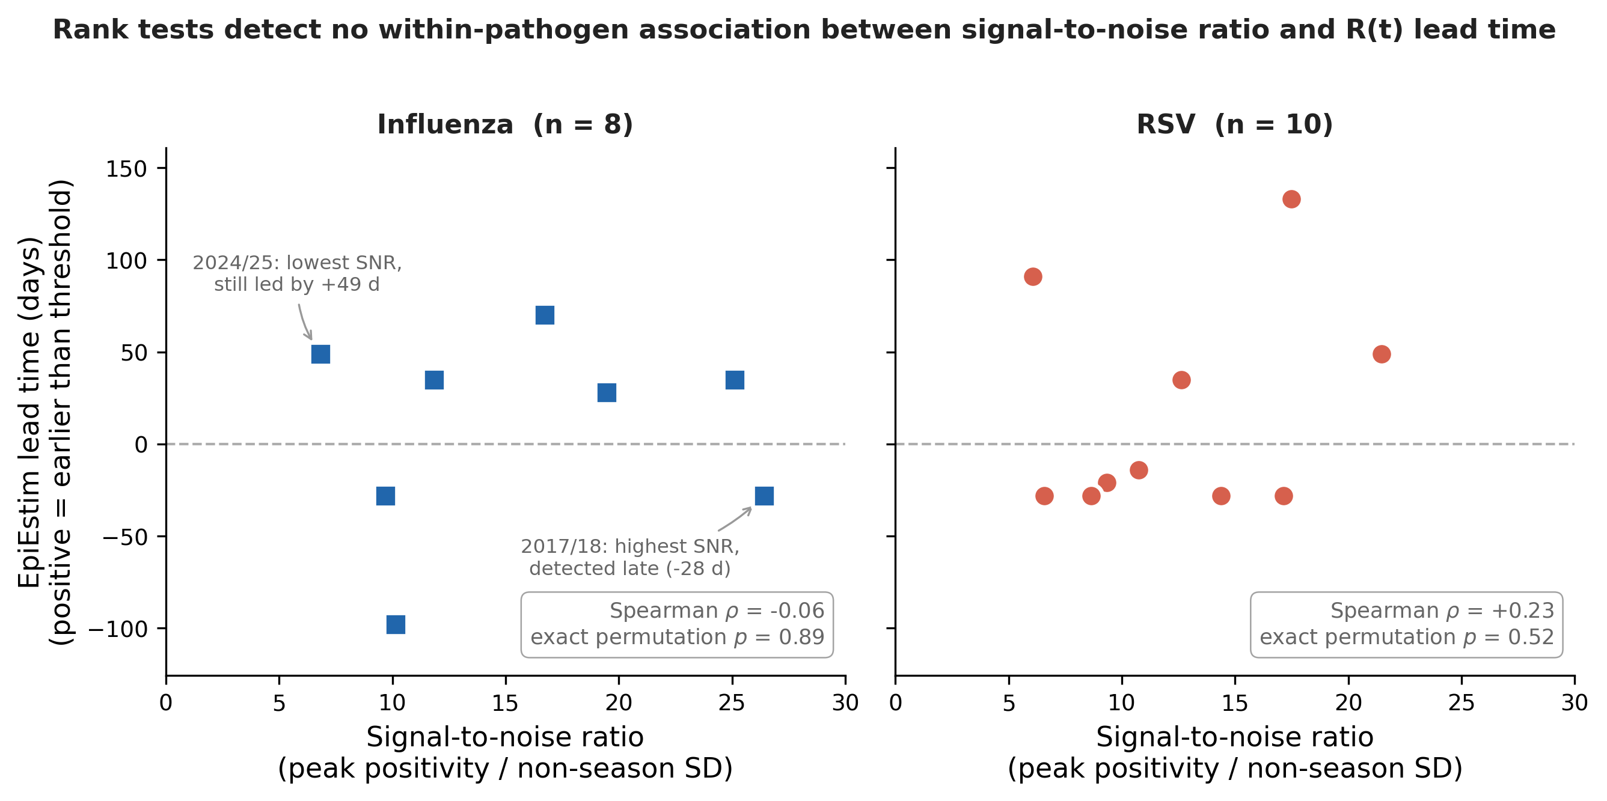
Figure 2. Rank tests detect no within-pathogen association between signal-to-noise ratio and EpiEstim lead time. Lead time relative to the onset comparator (positive = earlier than the threshold) against the season signal-to-noise ratio, defined as peak positivity divided by the non-season standard deviation, for 8 influenza seasons and 10 RSV seasons; every season in both panels is plotted. Spearman rank correlations are shown per panel with exact two-sided permutation p-values, enumerated over all 8! and 10! permutations rather than sampled. The two labelled influenza seasons are the extremes of the signal-to-noise range and run in opposite directions to the hypothesised relationship. At these sample sizes a non-significant rank test does not establish that no association exists. Lead times and signal-to-noise ratios are listed in snr_analysis_results.csv and the correlations in snr_within_pathogen_stats.csv.

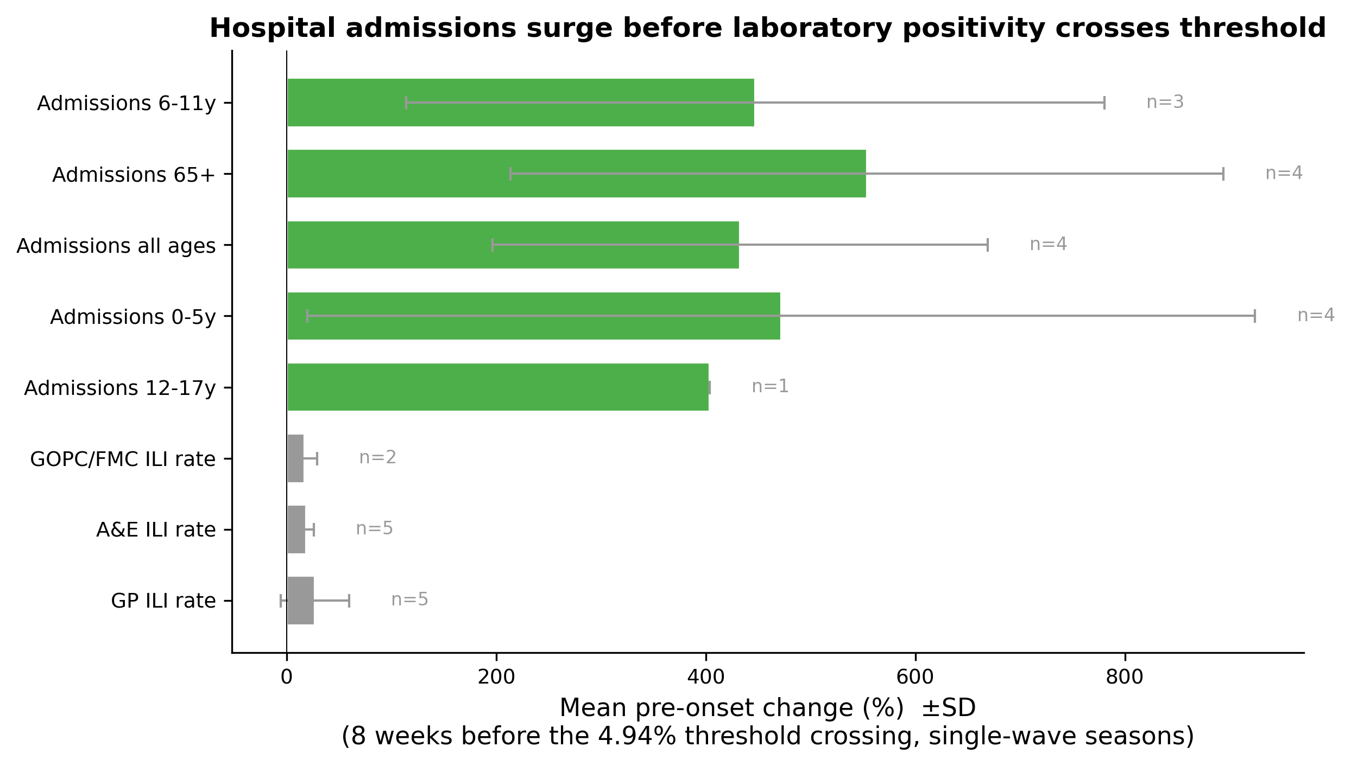
Figure 3. Pre-onset amplification by surveillance channel. Mean percentage change (bars, with SD) in each channel over the 8 weeks before laboratory positivity crossed the CHP 4.94% threshold, single-wave influenza seasons; n is the number of seasons contributing a value. Values are listed in Supplementary Table S2.

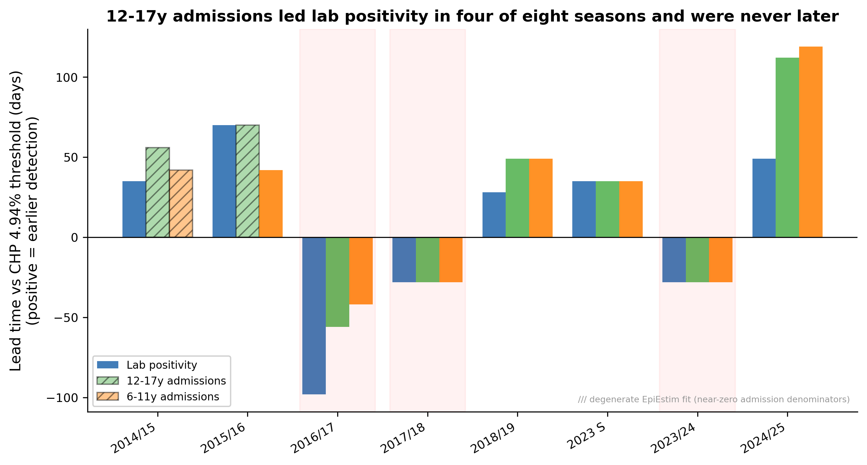
Figure 4. Admissions-based versus positivity-based onset detection. EpiEstim lead time relative to the CHP 4.94% threshold for laboratory positivity and for 12–17 and 6–11 year hospital admissions across 8 influenza seasons (positive = earlier detection). Hatched bars: degenerate EpiEstim fits caused by near-zero admission denominators (2014/15 and 2015/16). Shaded seasons: multi-wave (2016/17, 2017/18, 2023/24). Admissions led positivity in four of the eight seasons and were later in none; the paired test on the 12–17 year channel is not significant (W = 10.0, one-sided p = 0.0625, which is the exact test’s floor at four non-zero pairs). The plot title states that count and direction; the bars, hatching and shaded spans are unchanged from v9.

